Create a new table called Sales_order_info as a derived table from the above then it should have Product_ID ,Category, Sub_Category ,Product_Name ,Sales ,Quantity , per_quantity_price , sales_type ,Discount ,Profit , Loss

**CODE:**

**CREATE TABLE Sales_order_info AS**

**SELECT Product_ID ,Category, Sub_Category ,Product_Name ,Sales ,Quantity ,Discount ,Profit FROM sales_purchase_data;**

**ALTER table Sales_order_info Add column (per_quantity_price int, sales_type varchar(20), Loss int);**

1) product id should be in this format

ex FUR-BO-10001798 to 10001798

**CODE:**

**UPDATE Sales_order_info**

**SET Product_ID = SUBSTRING_INDEX(Product_ID, '-', -1)**

**OUTPUT:**

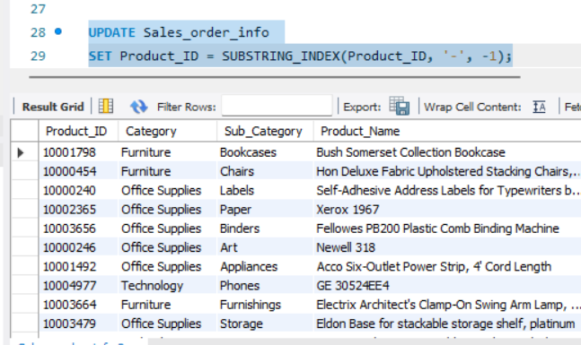

2) per_quantity_price should be output of Sales / Quantity of each customer records

**CODE:**

**SELECT Product_ID, (Sales / Quantity) AS per_quantity_price**

**FROM Sales_order_info;**

**OUTPUT:**

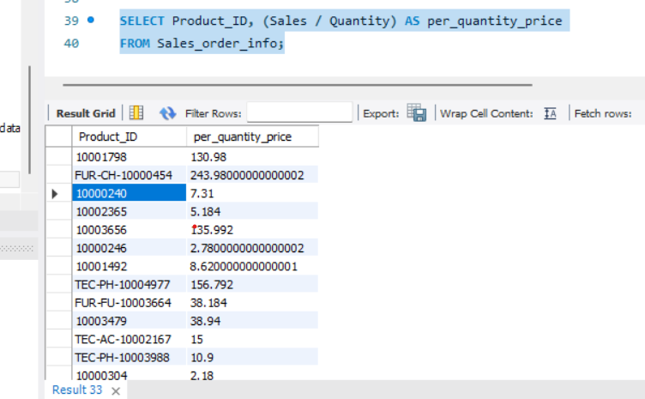

3) sales_type should be 3 categories

if sales are higher than 1000 then 'Super'

if sales are higher than 400 but lesser than 1000 then 'Average'

if sales are lesser than 400 then 'low'

**CODE:**

**SELECT Sales,**

**CASE**

**WHEN Sales > 1000 THEN 'Super'**

**WHEN Sales > 400 AND Sales <= 1000 THEN 'Average'**

**WHEN Sales <= 400 THEN 'Low'**

**END AS Sales_type**

**FROM Sales_order_info;**

**OUTPUT:**

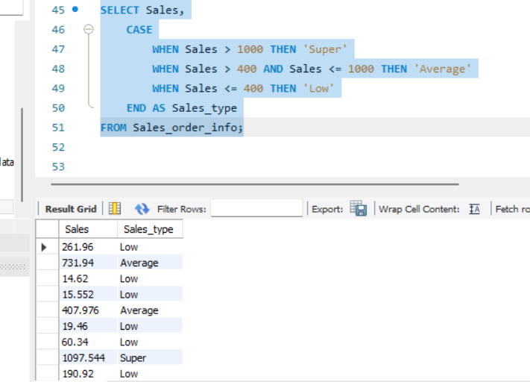

4)Loss will be 1 if profit is negative

**CODE:**

**SELECT profit,**

**CASE**

**when profit < 0 then 1**

**ELSE 'positive profit'**

**END as Lose**

**FROM Sales_order_info;**

**OUTPUT:**

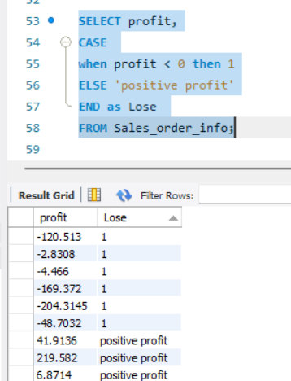

------Use single select statements to execute the below

5) Count of distinct order_ids in the sales_purchase_data_updated table

**CODE:**

**select count( distinct Order_ID) as Distinct_orderID from customerinfo;**

**OUTPUT:**

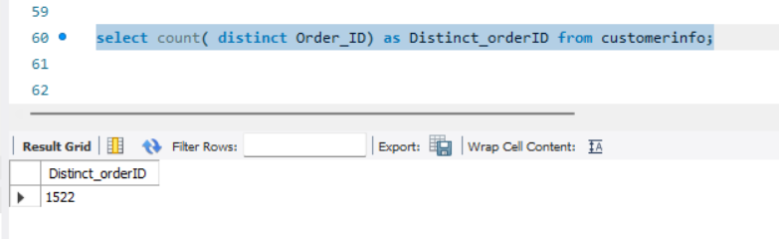

6) Count of Unique product names in Sales_order_info

**CODE:**

**SELECT count( DISTINCT Product_name) as unique_product_name_count from Sales_order_info;**

**OUTPUT:**

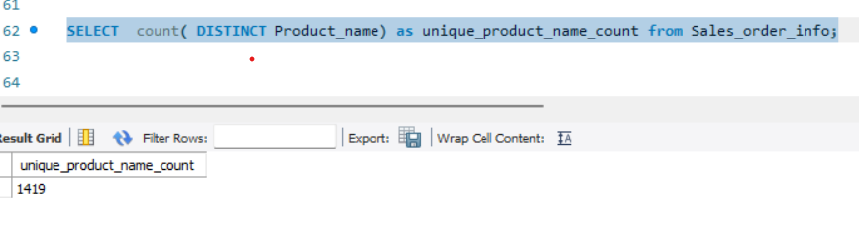

7) Count of distinct Segments in the sales_purchase_data_updated table

**CODE:**

**SELECT count( DISTINCT Segment) as Distinct_Segments from sales_purchase_data;**

**OUTPUT:**

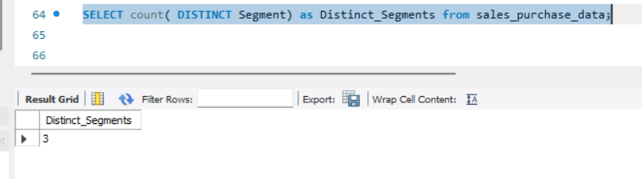

8) Recent order date in sales_purchase_data_updated table

**CODE:**

**SELECT MAX(Order_Date) AS Recent_Order_Date FROM customerinfo;**

**OUTPUT:**

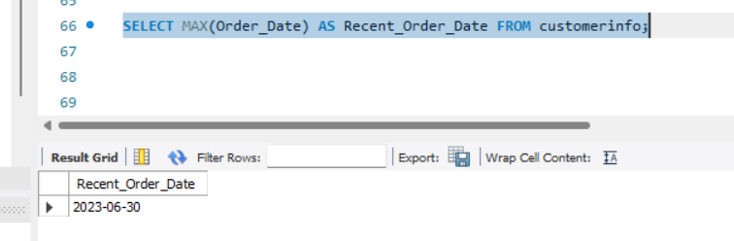

9)Old order date in sales_purchase_data_updated table

**CODE:**

**SELECT MIN(Order_Date) AS Recent_Order_Date FROM customerinfo;**

**OUTPUT:**

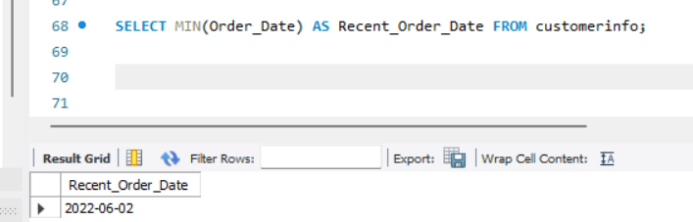

10) Customer info of all the columns for the maximum order date

**CODE:**

**SELECT * FROM customerinfo WHERE Order_Date =( SELECT MAX(Order_Date) from customerinfo) ;**

**OUTPUT:**

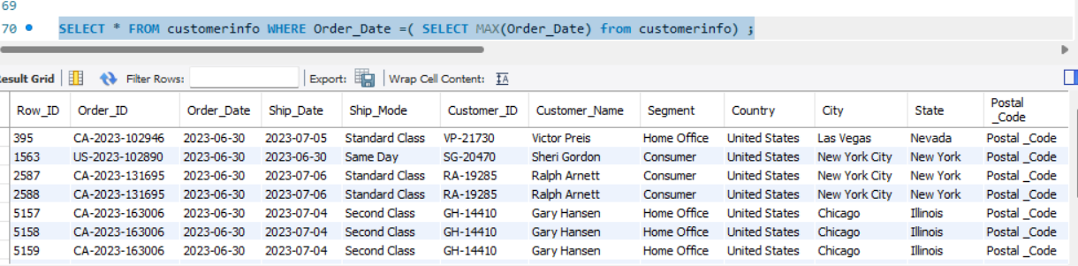

11) No .of Unique Customers from Texas and Newyork

o/p No_of_cust_texas | No_of_cust_New_york

**CODE:**

**SELECT COUNT(DISTINCT customer_id) AS no_of_cust_texas,**

**COUNT(DISTINCT customer_id) AS no_of_cust_new_york**

**FROM customerinfo**

**WHERE state = 'Texas' OR state = 'New York';**

**OUTPUT:**

